Connecticut Equine Development Center, LLC

at
Lexi’s Place Farm
Higganum, CT
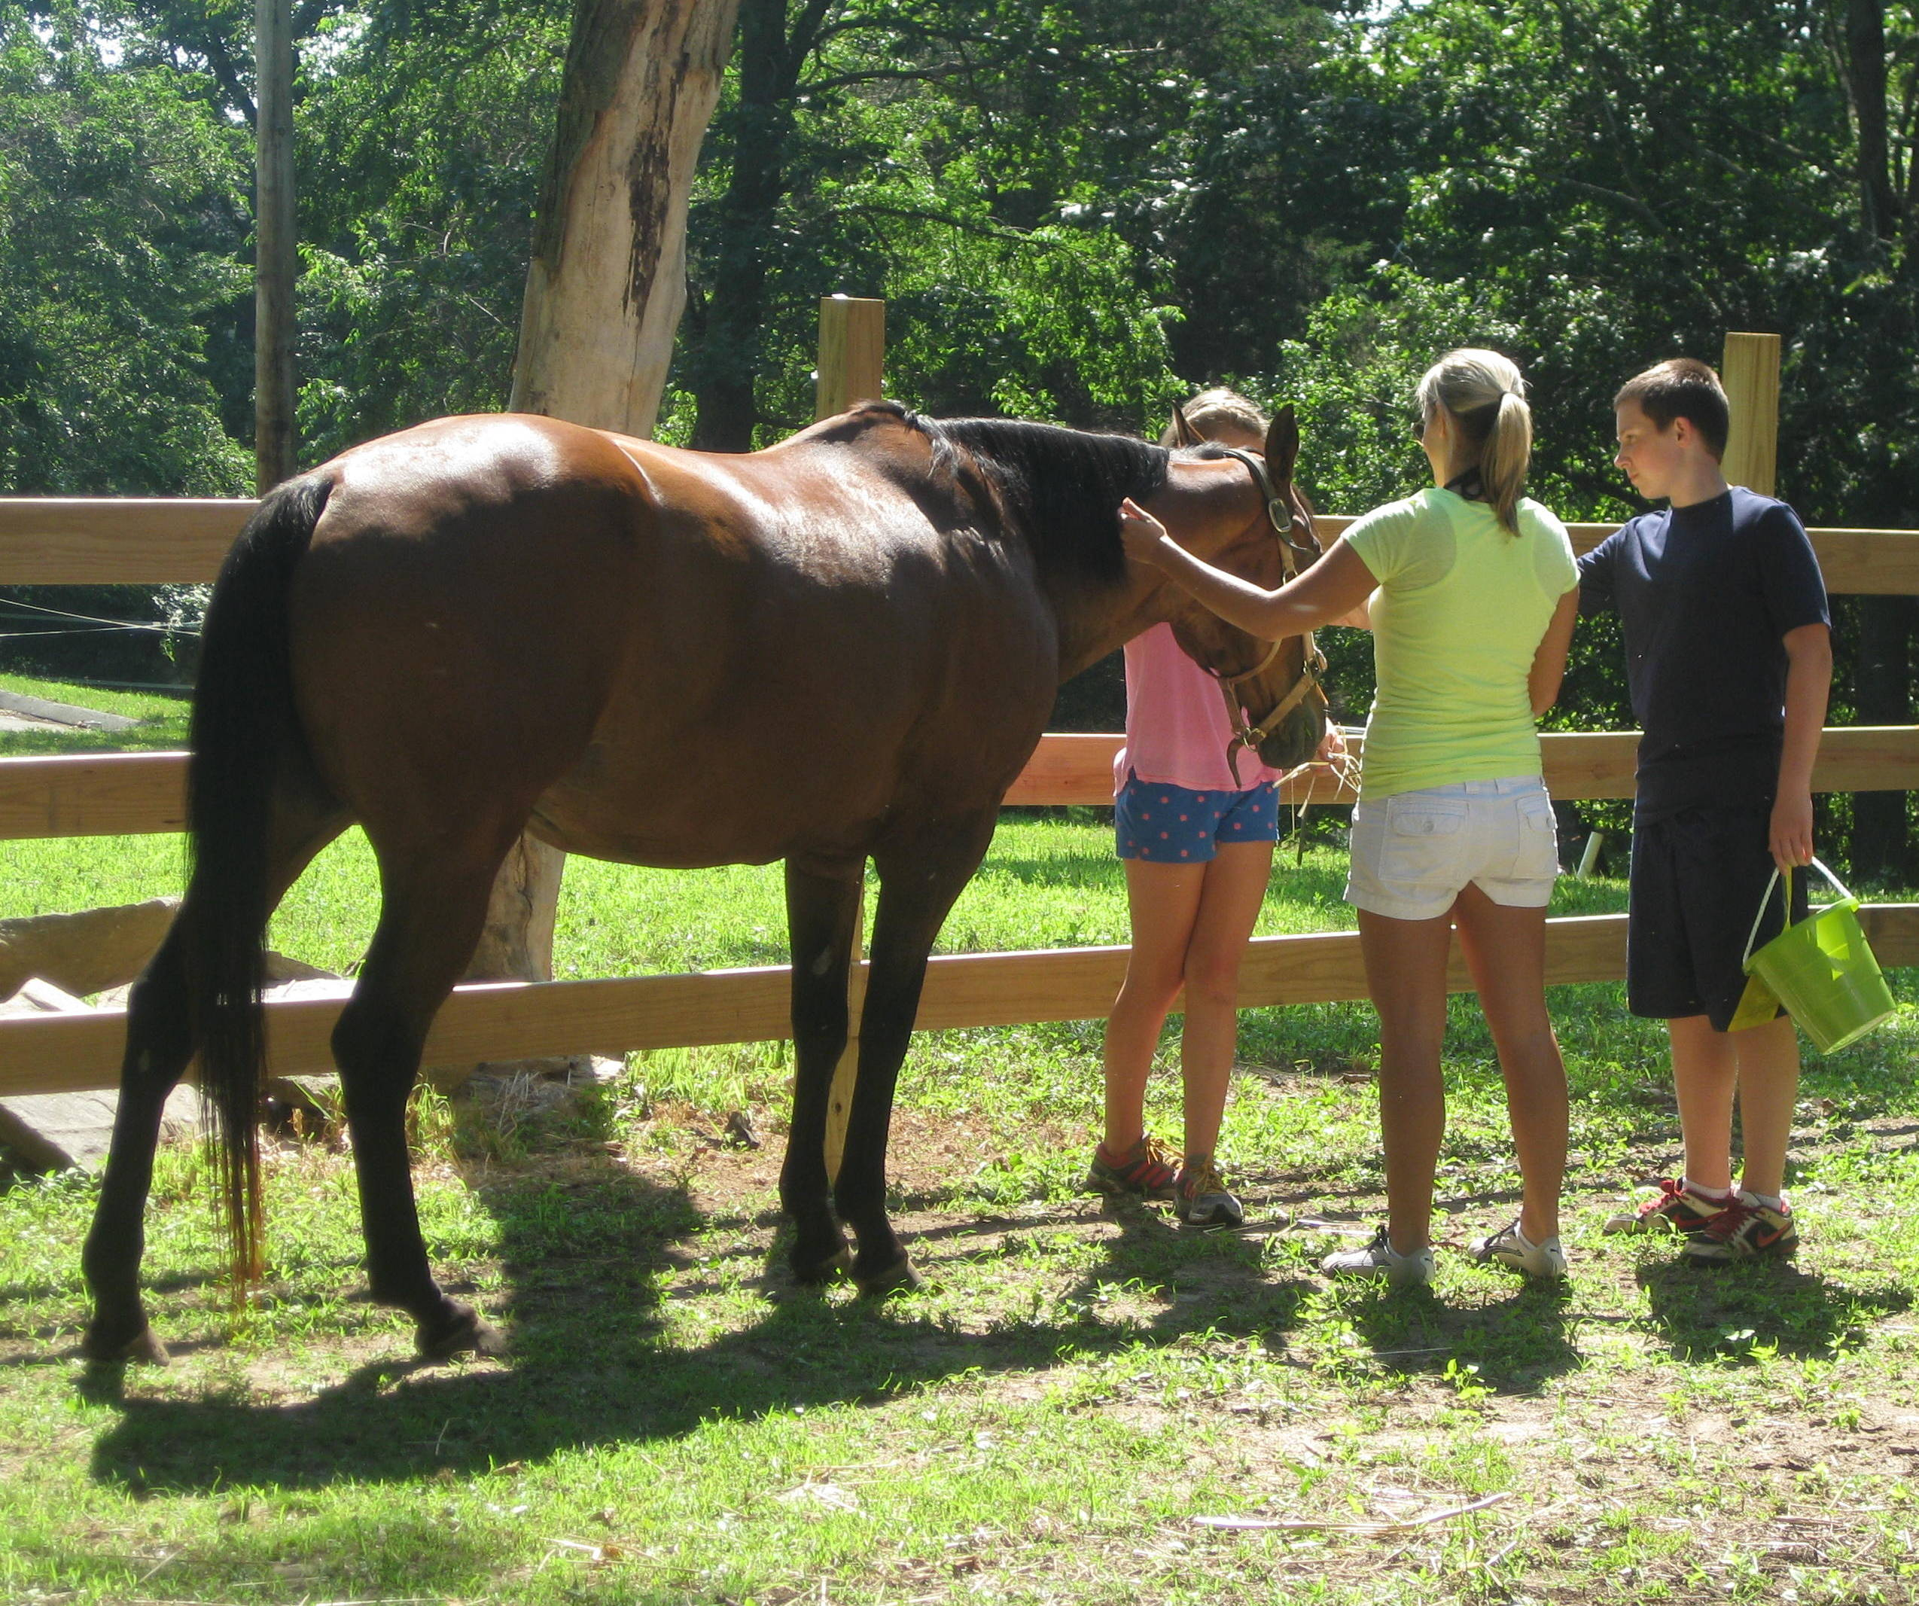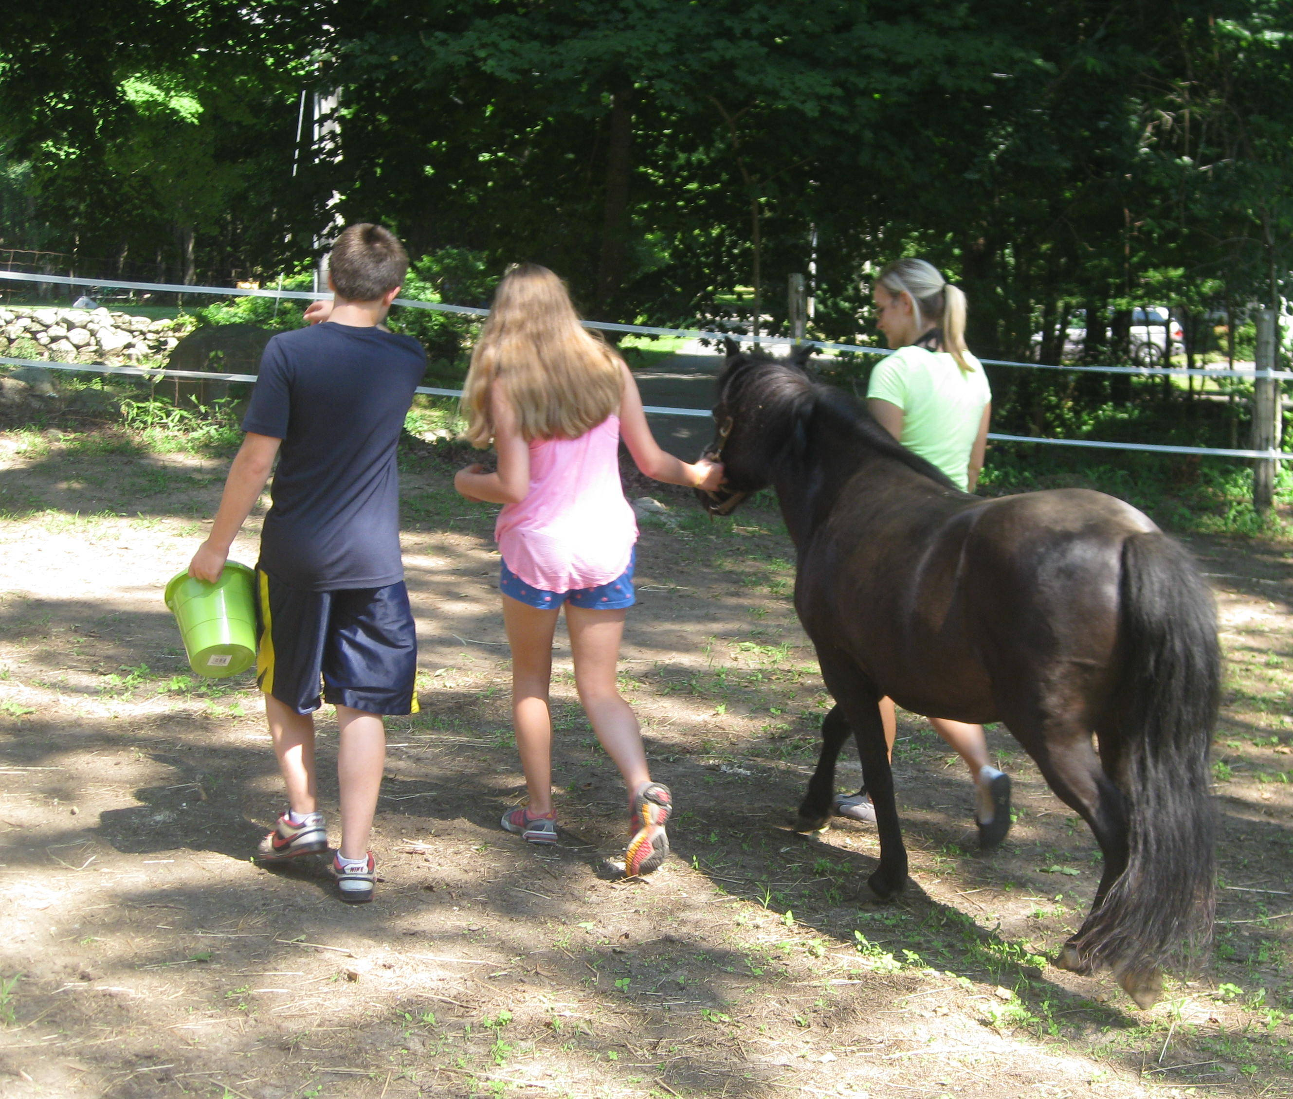

EQUI-LEADERS
Positive Youth/Staff Development and Leadership
Youth and Horses Team up for Learning!

Equi-leaders is a positive youth development workshop for your youth leaders! This one day workshop offers an opportunity for your youth and staff to come together with horses to gain and strengthen communication, problem solving, team work, and confidence building skills. Come join our EAGALA/PATH certified facilitators and horses for a fun and educational day of growth, learning, and adventure!

Please contact us about details and how this program can be tailored for your program.

THIS PROGRAM CAN ALSO BE TAILORED FOR ADULTS AS A TEAM BUILDING/PROFESSIONAL DEVELOPMENT OPPORTUNITY

For further information contact:
Allison Behnke, MSW/MA, Director
(860) 759-3484 or ctequine@gmail.com

