Connecticut Equine Development Center, LLC

at
Lexi’s Place Farm
Higganum, CT
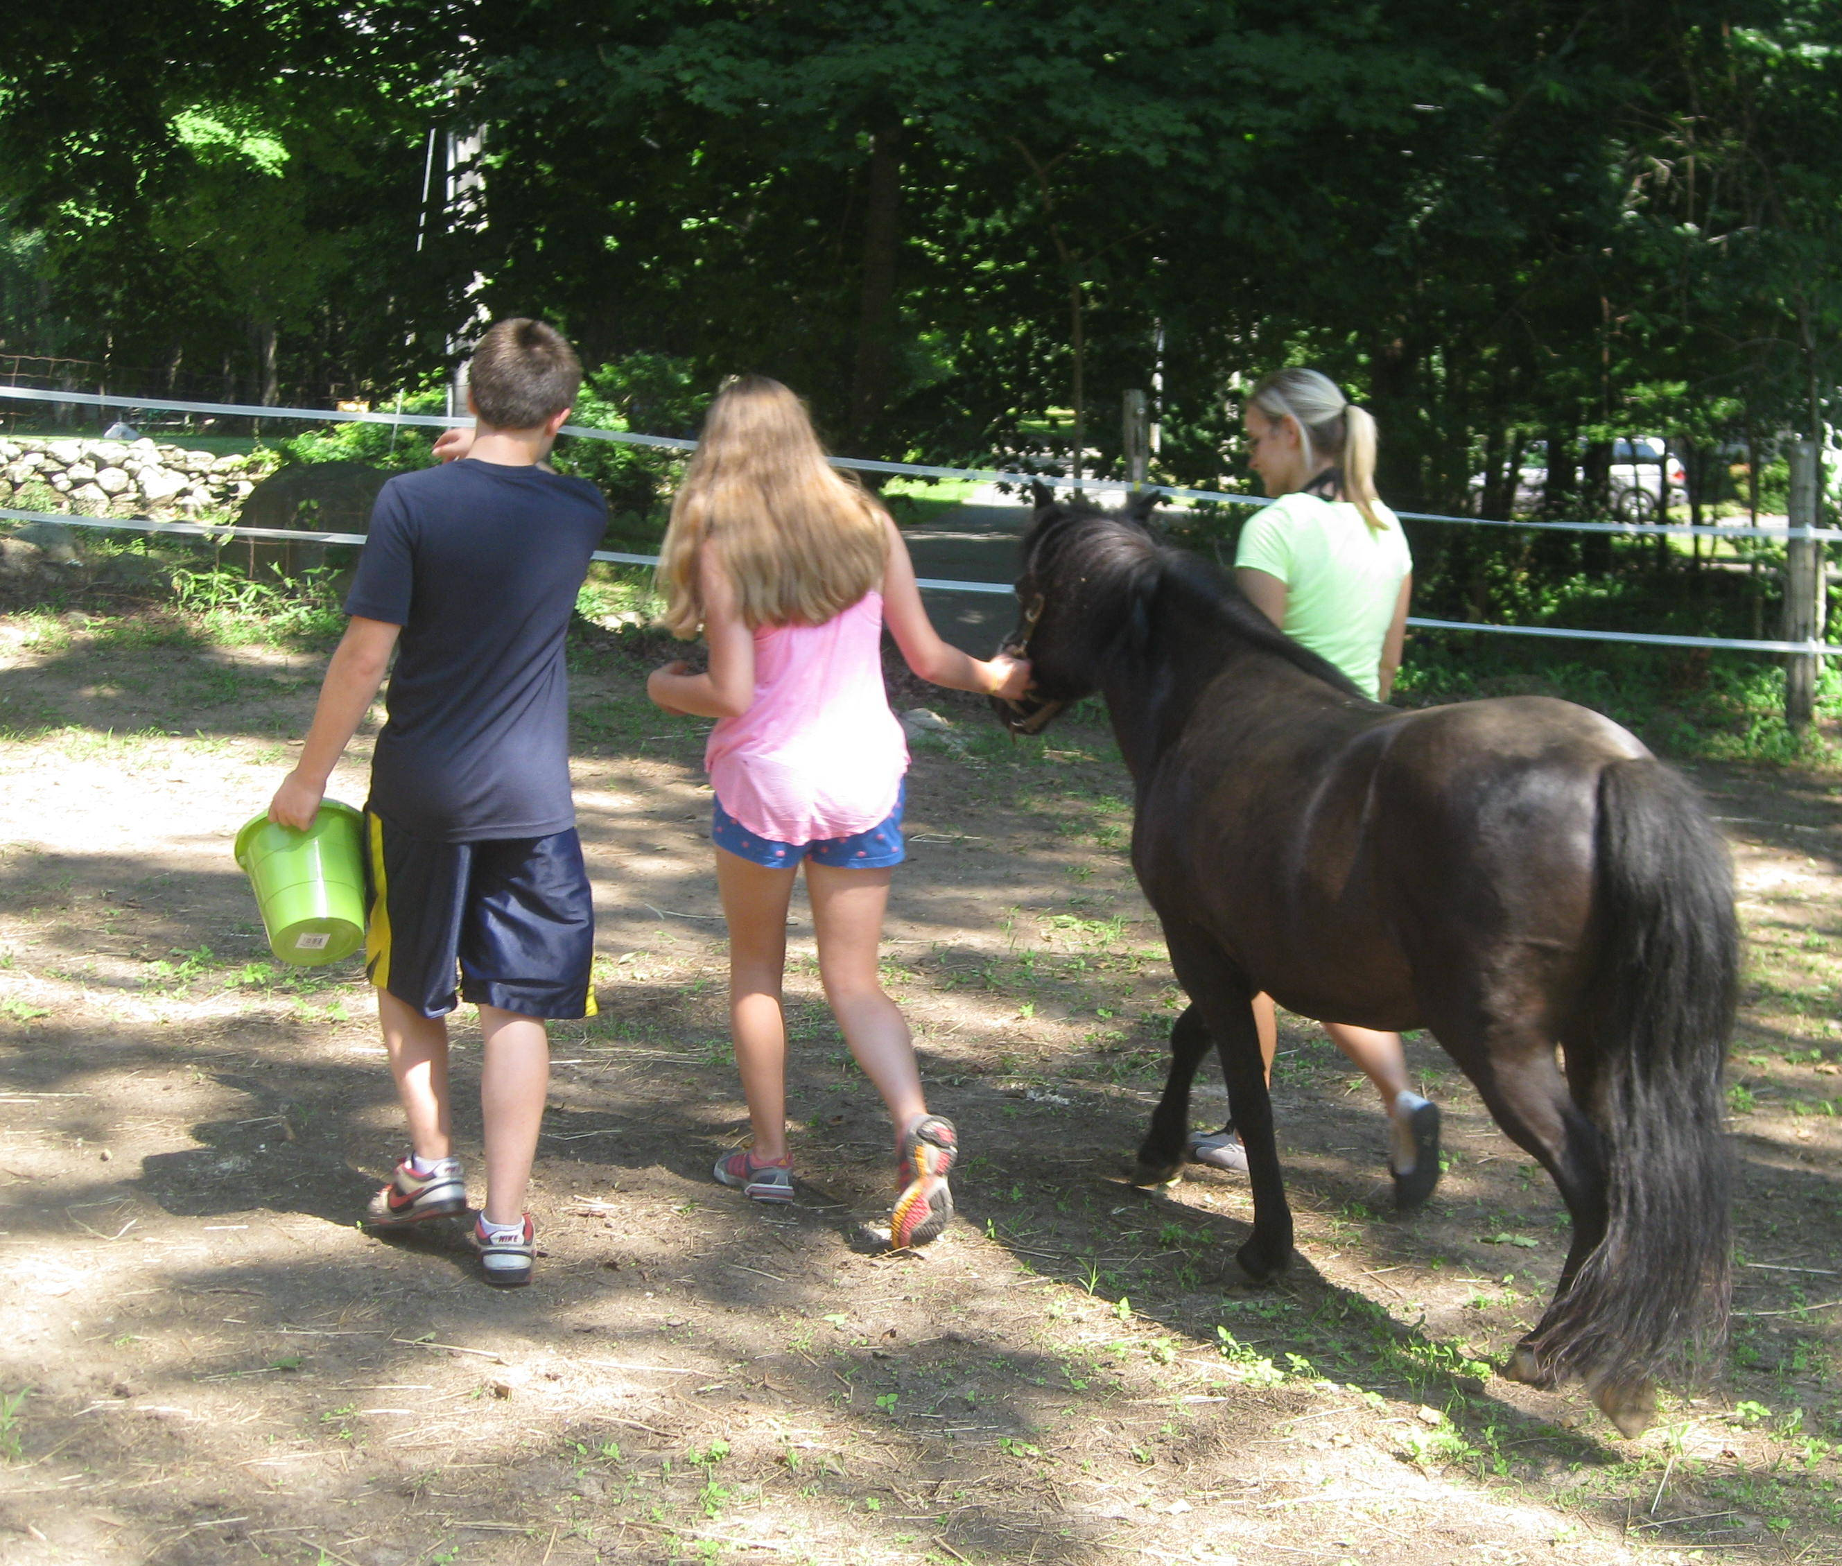

EQUI-TEAM
Positive Staff Development, Teamwork
and Leadership Training

Equi-TEAM is a teambuilding workshop for your organization, business, and staff members! This ½ day workshop offers an opportunity for your staff to come together with horses to gain and strengthen communication, problem solving, team work, and confidence building skills. Come join our EAGALA/PATH certified facilitators and horses for a fun and educational day of growth, learning, communication, and adventure!

Please contact us about details and how this program can be tailored for your group.

For further information contact:
Allison Behnke, MSW/MA, Director
(860) 759-3484 or ctequine@gmail.com

