Connecticut Equine Development Center, LLC
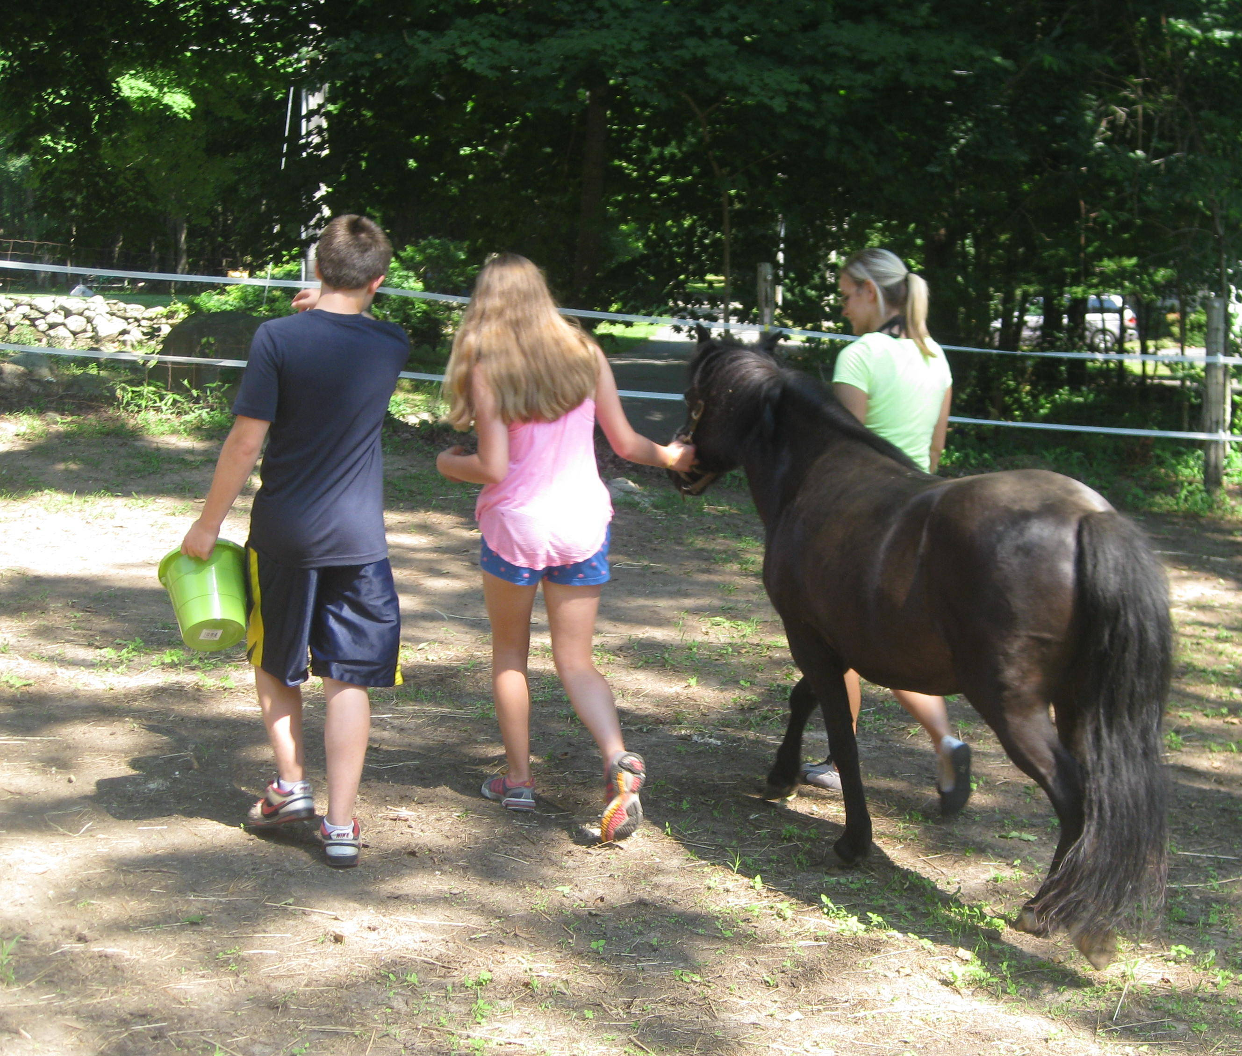
at
Lexi’s Place Farm
Higganum, CT

EQUI-HEARTS After-School Group
Ages 12-17
Youth and Horses Team up for Support!

Equi-hearts is a positive youth development and peer support program providing a therapeutic network for youth through fun and engaging activities with horses, peers, and facilitators. Horses teach hands on lessons that allow youth to learn more about themselves and their ability to connect with others. Participants will develop and enhance leadership, teamwork, communication, problem solving, self-control, and confidence building skills with the support of EAGALA certified counselors, educators, and equine specialists.
Learn About Horses and Yourself! Interact With Horses!
Learn the Lessons Horses Teach! Make New Friends! Explore Nature!

- Six Week Fall Program- once a week for one hour
- Wednesdays 5:45-6:45PM September 24-October 29 2014
- Boys and Girls
- $200.00 for six weeks
For further information and to register contact:
http://ctequine.wix.com/cedc (further programs)
Allison Behnke, MSW/MA, Director
(860) 759-3484 or ctequine@gmail.com

